Sri Lanka Institute of Information

Technology



Lab Submission

Lab sheet 04

**IT24101147**

**Warnakulasinhage S.N.A**

**Probability and Statistics| IT2120**

B.Sc. (Hons) in Information Technology

**Exercise**

1)



2),3)

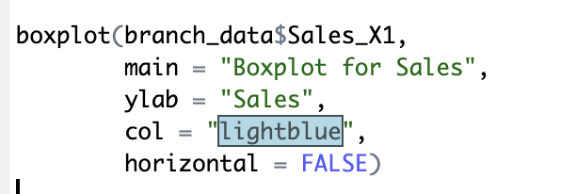

4)

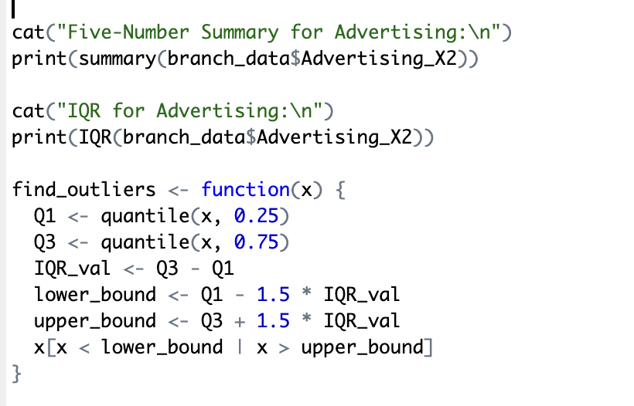

5)

